PROGETTO 2 REGISTRATORE DI TEMPERATURA

Il progetto digitale qui proposto è un "Registratore di Temperatura". La motivazione per farlo è in alcuni progetti misti analogico-digitali già attivi a LNL (sismografi, registratore di punto di rugiada) si sono osservate derive forse legate alle variazioni di temperatura giornaliere e stagionali.
Quindi, meglio verificare!

Per realizzare questo progetto si userà un sensore di temperatura (DS18B20 Temperature Sensor) in cui l’elettronica di digitalizzazione e trasmissione dati (ADC, gestore di bus seriale) è già integrata nel modulo con il sensore.

I problemi da risolvere sono legati alla lettura del dato e alla registrazione dei file con le misure e l’informazione aggiuntiva di data-ora.

Prosecuzione: si tratta di graficare i dati, per una più immediata ed agevole lettura e renderli disponibili su un sito web.
Con gli studenti è importante arrivare a registrare i dati; grafici e sito web possono essere lasciati alla loro fantasia e stile.
Condividere l'apprendimento e i progetti è sempre molto importante, prima di tutto con gli studenti. Potrebbe anche essere utile creare un blog per descrivere anche questo progetto.

---

Qui di seguito sono riportare 2 tracce per la gestione iniziale del DS18B20, la prima utilizza il driver “nativo” e poi legge e seleziona il dato reso disponibile nel file-system.
La seconda traccia usa pure il driver nativo, ma anche una libreria python “ad hoc” che consente di semplificare un po’ il programma di lettura.

Suggerimenti:
1. abilitare 1-Wire (da Preferences → Raspberry Pi Configuration → Interfaces)
( 1-bis sudo apt-get update; sudo apt-get upgrade; sudo apt-get autoclena )
2. sudo modprobe w1-therm
3. cd /sys/bus/w1/devices
4. ls 28-00000xxxxxxx
5. cd 28-0000054bfcc0
6. cat w1_slave
questo mostra la temperatura letta dal sensore:
t=28625, indica una temperatura di 28.625 gradi Celsius.

Connessioni:

Rosso: pin 4 (5 V)
Nero: pin 6 (ground)
Bianco: pin 7 (bus – GPIO-3)

1. Raspberry Pi DS18B20 Temperature Sensor Tutorial
The DS18B20 temperature sensor is perfect for projects like weather stations and home automation systems. Few sensors are this easy to set up on the Raspberry Pi. They’re the same size as a transistor and use only one wire for the data signal. They’re also extremely accurate and take measurements quickly. The only other component you need is a 4.7K Ohm or 10K Ohm resistor.

Digital Temperature Sensors vs. Analog Temperature Sensors
Digital temperature sensors like the DS18B20 differ from analog thermistors in several important ways. In thermistors, changes in temperature cause changes in the resistance of a ceramic or polymer semi-conducting material. Usually, the thermistor is set up in a voltage divider, and the voltage is measured between the thermistor and a known resistor. The voltage measurement is converted to resistance and then converted to a temperature value by the micro-controller.
Digital temperature sensors are typically silicon based integrated circuits. Most contain the temperature sensor, an analog to digital converter (ADC), memory to temporarily store the temperature readings, and an interface that allows communication between the sensor and a micro-controller. Unlike analog temperature sensors, calculations are performed by the sensor, and the output is an actual temperature value.

About the DS18B20
The DS18B20 communicates with the “One-Wire” communication protocol, a proprietary serial communication protocol that uses only one wire to transmit the temperature readings to the micro-controller.
The DS18B20 can be operated in what is known as parasite power mode. Normally the DS18B20 needs three wires for operation: the Vcc, ground, and data wires. In parasite mode, only the ground and data lines are used, and power is supplied through the data line.
The DS18B20 also has an alarm function that can be configured to output a signal when the temperature crosses a high or low threshold that’s set by the user.
A 64 bit ROM stores the device’s unique serial code. This 64 bit address allows a micro-controller to receive temperature data from a virtually unlimited number of sensors at the same pin. The address tells the micro-controller which sensor a particular temperature value is coming from.

Technical Specifications
- -55°C to 125°C range
- 3.0V to 5.0V operating voltage
- 750 ms sampling
- 0.5°C (9 bit); 0.25°C (10 bit); 0.125°C (11 bit); 0.0625°C (12 bit) resolution
- 64 bit unique address
- One-Wire communication protocol

Connect the DS18B20 to the Raspberry Pi
The DS18B20 has three separate pins for ground, data, and Vcc:
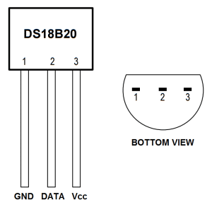

Wiring for SSH Terminal Output
Follow this wiring diagram to output the temperature to an SSH terminal:
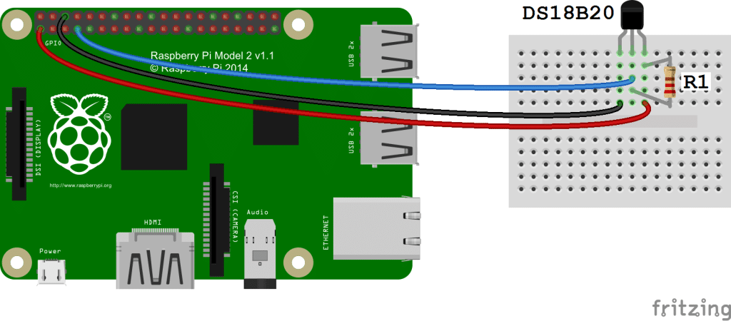
R1: 4.7K Ohm or 10K Ohm resistor

IMPORTANT: connect the device to the GPIO with the Raspberry OFF
black: ground – red: 3.3 V – white-blue: 4

Enable the One-Wire Interface
We’ll need to enable the One-Wire interface before the Pi can receive data from the sensor. Once you’ve connected the DS18B20, power up your Pi and log in, then follow these steps to enable the One-Wire interface:
1. At the command prompt, enter: sudo nano /boot/config.txt, then add this to the bottom of the file (or use Preferences→ Rasperry PI configuration)
dtoverlay=w1–gpio
2. Exit Nano, and reboot the Pi (sudo reboot)
3. Log in to the Pi again, and at the command prompt enter
sudo modprobe w1–gpio (NON SERVE PIU’, a aprtire da una certa release)
4. Then enter
sudo modprobe w1-therm
5. Change directories to the /sys/bus/w1/devices directory by entering:
cd /sys/bus/w1/devices
6. Now enter ls to list the devices:
28-000006637696 w1_bus_master1 is displayed in my case.
7. Now enter cd 28-XXXXXXXXXXXX (change the X’s to your own address)
For example, in my case I would enter: cd 28-000006637696
8. Enter cat w1_slave which will show the raw temperature reading output by the sensor:
Here the temperature reading is t=28625, which means a temperature of 28.625 degrees Celsius.
9. Enter cd to return to the root directory
That’s all that’s required to set up the one wire interface. Now you can run one of the programs below to output the temperature to an SSH terminal.

Programming the Temperature Sensor
The examples below are written in Python. If this is your first time running a Python program, check out our tutorial How to Write and Run a Python Program on the Raspberry Pi to see how to save and run Python files.

Temperature Output to SSH Terminal
This is a basic Python program that will output the temperature readings in Celsius and Fahrenheit to your SSH terminal:
import os
import glob
import time
// os.system('modprobe w1-gpio')
os.system('modprobe w1-therm')
base_dir = '/sys/bus/w1/devices/'
device_folder = glob.glob(base_dir + '28*')[0]
device_file = device_folder + '/w1_slave'
def read_temp_raw():
f = open(device_file, 'r')
lines = f.readlines()
f.close()
return lines
def read_temp():
lines = read_temp_raw()
while lines[0].strip()[-3:] != 'YES':
time.sleep(0.2)
lines = read_temp_raw()
equals_pos = lines[1].find('t=')
if equals_pos != -1:
temp_string = lines[1][equals_pos+2:]
temp_c = float(temp_string) / 1000.0
temp_f = temp_c * 9.0 / 5.0 + 32.0
return temp_c, temp_f
while True:
print(read_temp())
time.sleep(1)
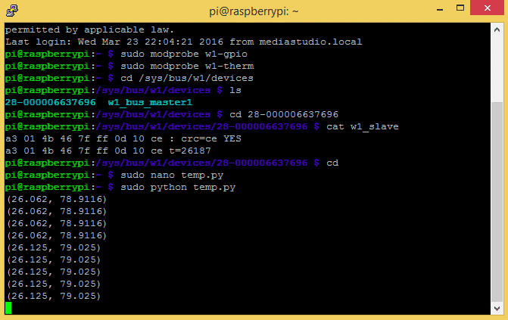

2. DS18B20 Temperature Sensor With Python (Raspberry Pi)

What will you need?
- A Raspberry Pi (any model)
- A DS18B20 Temperature Sensor
- A 4.7K Ohm Resistor (Colour Code: Yellow Purple Red Gold)
- 3 jumper cables.
- An Internet connection for your Raspberry Pi

Getting Started
With your Raspberry Pi turned off, build the circuit according yo the diagram below.
The DS18B20 is placed into the breadboard so that the flat side faces you.
- The black jumper cable goes from GND, which is the third pin down on the right column to the first pin of the DS18B20.
- The yellow jumper cable goes from the fourth pin down on the left column and is connected to the middle pin of the DS18B20.
- The red jumper cable goes from the top left pin of the Raspberry Pi to the far right pin of the DS18B20.
The Resistor connects the RIGHT pin to the MIDDLE pin. This is called a pull up resistor and is used to ensure that the middle pin is always on. In the diagram I had to use a spare red wire to show this connection. But in reality, using the resistor to make the connection, as per this photo is the best way.
black: ground – red: 3.3 V – white-blue-yellow : 4

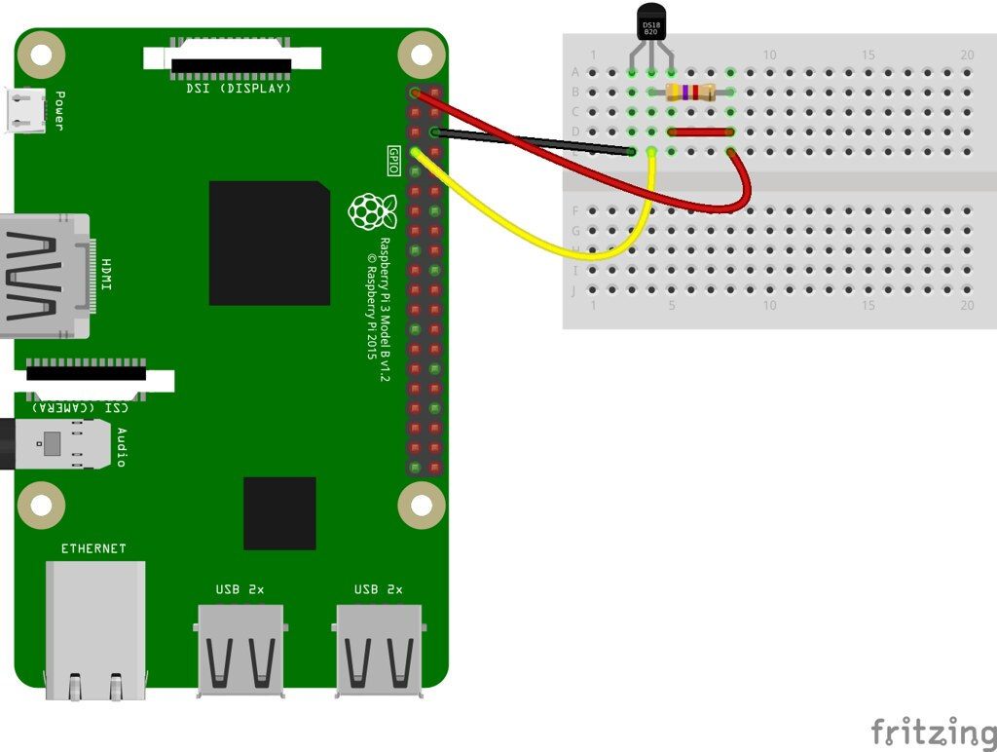
Now attach your keyboard, mouse, HDMI and power to your Raspberry Pi and boot to the desktop.

Configuring the Raspberry Pi
We now need to take two steps to enable our DS18B20 for use.

Install the Python Library
Firstly we need to install a Python library, pre-written code that enables the Python code that we shall later write to talk to the sensor. The Python library is called w1thermsensor and to install it we need to use the Terminal. You can find the terminal icon in the top left of the screen. It looks like...

When the terminal opens, enter the following to install the library, just press ENTER to start.
sudo pip3 install w1thermsensor
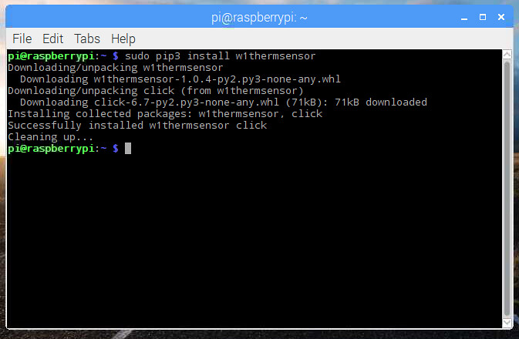
That's it, now you can close the Terminal window.

Enable the Interface
The DS18B20 uses a 1 wire serial interface, this is the middle pin of the sensor, that is connected to the Raspberry Pi via the yellow wire in the diagram. We need to tell our Raspberry Pi that we are using this pin and to do that we use the Raspberry Pi Configuration tool, found in the Preferences menu.
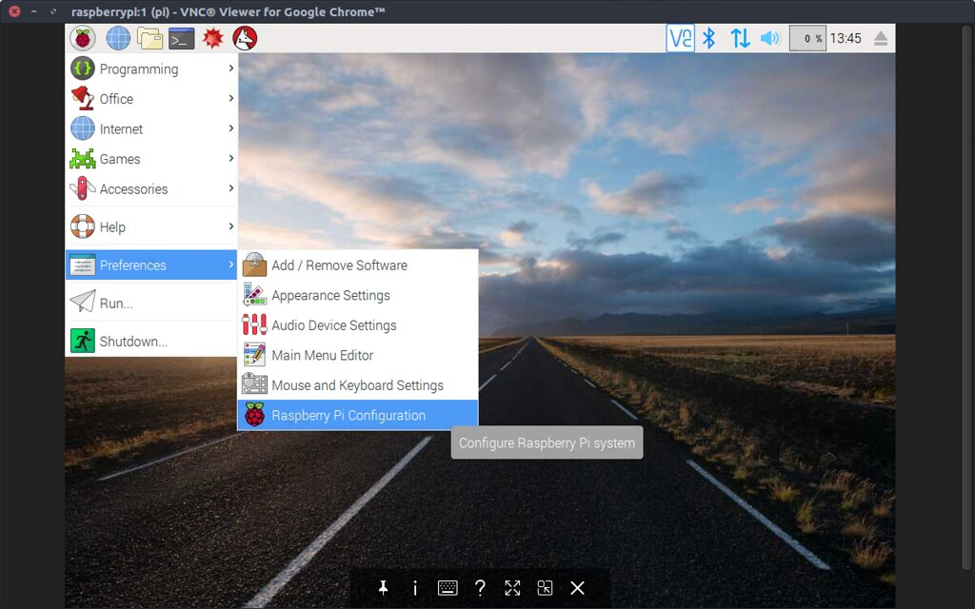
When it opens, click on the Interfaces tab and then click on Enable for the 1-Wire interface.
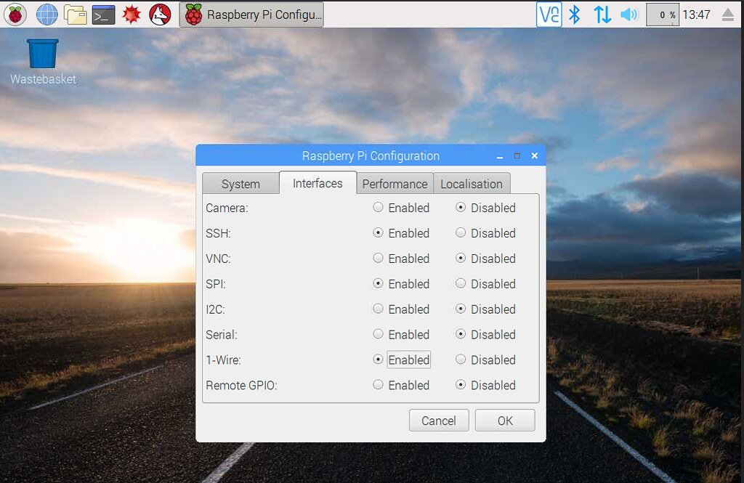
Now click on Ok and you will be asked to reboot, so go ahead and do that, and let the Raspberry Pi reboot to the desktop.
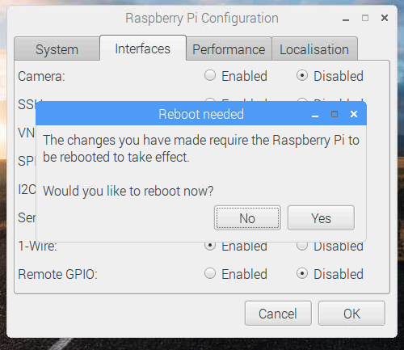

Writing the Python Code
Our project will gather the temperature from the DS18B20 sensor every one second and print it to the screen. The code will run forever.
To write the code we shall use the Python 3 Editor found in the Programming menu.
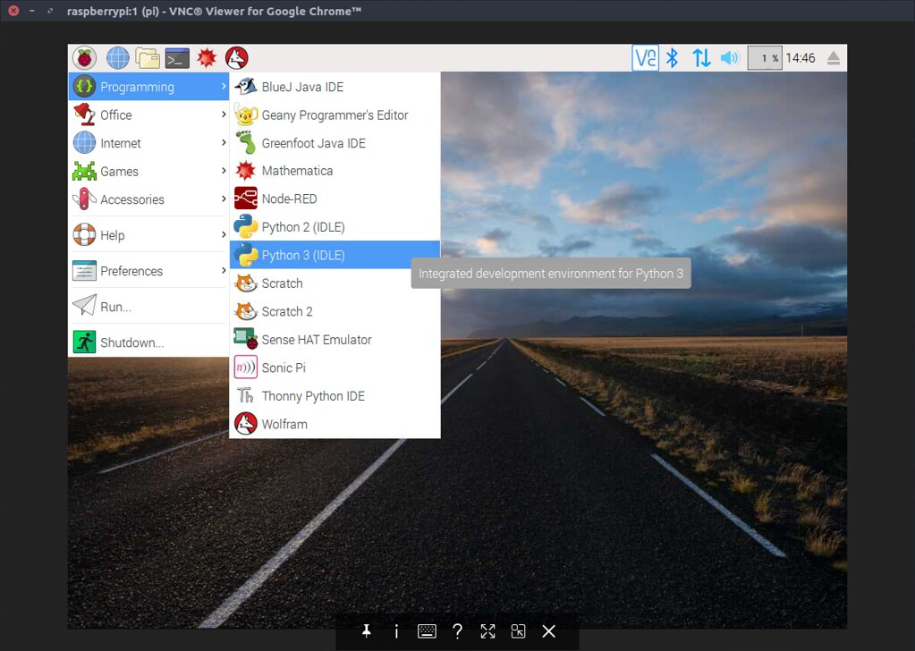
When the application opens, click on File >> New to create a new blank document. In this new window, click on File >> Save and call the project temperature-sensor.py
Remember to save your work often!

Importing the libraries
The first step in any Python project that uses libraries is to import the libraries that we wish to use. In this case we import time to control how often the sensor data is collected, and we import w1thermsensor to enable our project to talk to the sensor.
So lets import the libraries.
import time
from w1thermsensor import W1ThermSensor

Sensor
Our next line is to create an object to store a connection the sensor. So rather than typing W1ThermSensor() everytime we want to use the sensor, we store the connection in an object called sensor.
sensor = W1ThermSensor()

Running in a loop
We'd like to get the temperature sensor data every second, and run forever. So let's use a while True loop to run the code inside of it forever.
while True:
Now the next lines of code are indented, this is how Python shows that this code belongs inside the loop that we have just created.
The first thing to do in our loop is to get the current temperature from the DS18B20 sensor, and then store it in a variable called temperature. Variables are boxes / containers into which we can store any data.
temperature = sensor.get_temperature()
Now that we have the data, lets print it to the screen using the print() function. But lets use the data in the form of a sentence that will tell the us what the temperature is in celsius. For this we use a little Python trick called string formatting, where we would like the temperature data to be printed in the sentence, we use an %s which will format the temperature data from an float (a number with a decimal place) to a string (text, characters that can be printed but not used in any mathematical equations)
print("The temperature is %s celsius" % temperature)
Our last line of Python code will tell the Raspberry Pi to wait for 1 second between taking a temperature reading.
time.sleep(1)
That's all of the code, so make sure that you save your work.

Complete Code Listing
Check that your code matches the code below before moving on.
import time
from w1thermsensor import W1ThermSensor
sensor = W1ThermSensor()
while True:
temperature = sensor.get_temperature()
print("The temperature is %s celsius" % temperature)
time.sleep(1)

Run the Code!
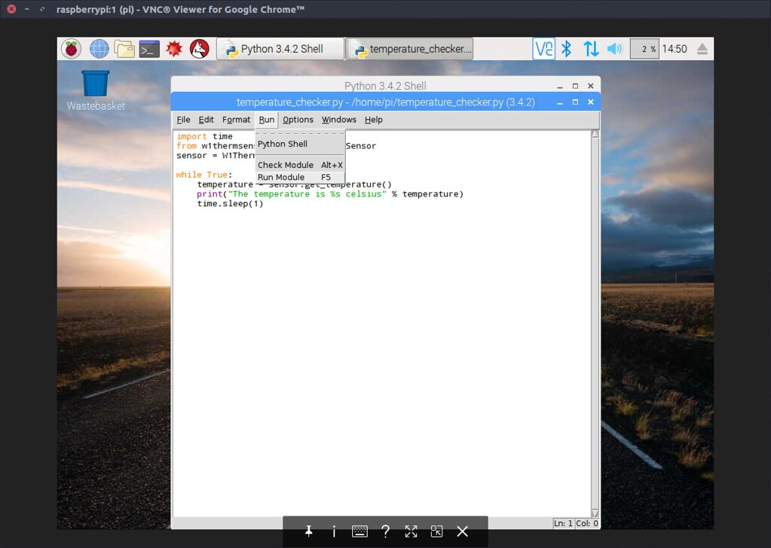
To run the code, click on Run >> Run Module and you will see the Python Shell window pop up and start displaying temperature data!
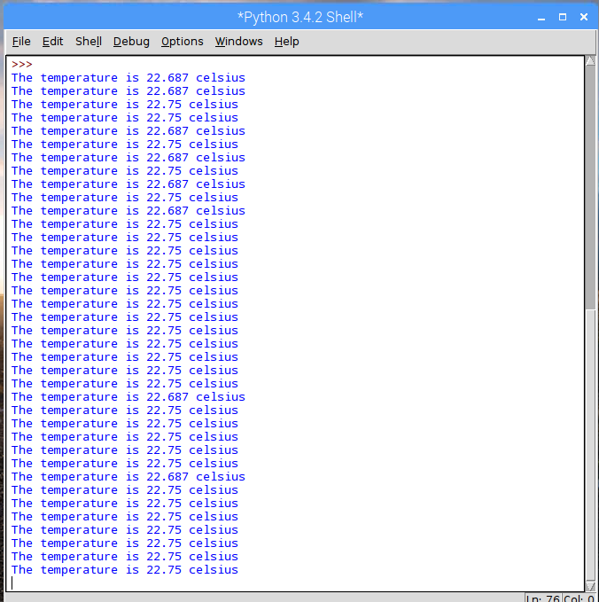

Congratulations, you have completed the project!

