Welcome to Week 1
1.2 Meet the team
1.3 Introduce yourself
1.4 How do we learn through success and failure?

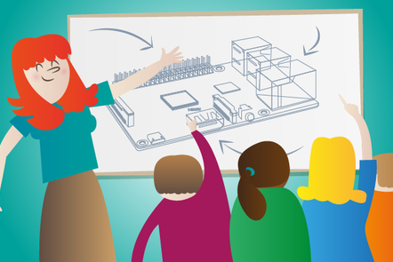
An Introduction to Raspberry PiIn this activity we'll share our methods of learning. You'll also learn how to set up and use a Raspberry Pi computer.
1.5 The Raspberry Pi (Computer video)
1.6 Setting up the software
1.7 Connecting all the things
1.8 Check your understanding quiz
1.9 Discussion of quiz questions
1.10 Troubleshooting your Raspberry Pi

Meet the team
Before you begin the course properly we’d like to introduce the team ...
Me: Stefania Canella
responsible for 2 of 6 LNL particke accelerators and managing the Raspberry Pi LNL educational resources, passionate about Open Education, ...
...
You: (students, some notes to be taken)
Gabriele, Chiara, Gianmarco, Riccardo.

Introduce yourself
The best way to learn is by collaborating with other amazing people.
With this in mind, we have two things for you to do today:
1) Introduce yourself to your fellow learners by commenting at the bottom of the page.
Think about answering these questions:
- what made you take the course?
- what are hoping to learn?
Together we will build a community who share ideas and inspire each other to learn along the way.

...

Week 1
Hello, and welcome to Physical Computing with Raspberry Pi and Python. In these labs you may learn a new skill, or dust off a few cobwebs.
The Raspberry Pi Foundation has a mission: to put the power of digital making into the hands of people all over the world.
These labs will introduce you to Physical Computing, showing you how easy it is to create systems that respond to, and control, part of the physical world using computer programs. You’ll develop your knowledge of simple electronics and computing, setting up a Raspberry Pi and writing your first program using the Python programming language. You’ll apply your new-found knowledge to a series of challenges, including controlling an LED with Python and using a button press to control a circuit.
You’ll also have the chance to develop ideas for using the Raspberry Pi and Python for your projects, and to connect with a network of digital makers.
We hope this labs will help build a movement of people to put the power of digital making into the hands of young people all over the world.
During this week you will :
- Consider the importance of success and failure when learning
- Set up your Raspberry Pi for the first time
- Write your first simple Python program
For this course, you will need:
- a Raspberry Pi (models B+ through to 3)
- a microSD card (8GB minimum) with our Raspbian operating system installed
- a monitor and HDMI cable (or VGA adaptor)
- a USB keyboard and mouse (or a computer to control the Pi)

The Raspberry Pi Computer
It may not look much like the computers you are used to, but this is because we are accustomed to seeing a computer in a case, with a monitor, keyboard and mouse attached.
The Raspberry Pi comes without any of these peripheral input, output and storage devices. It is known as a single board computer, and the fact that it comes without any additional peripherals, and uses hardware components more usually found in mobile phones and tablets, means it can be sold for as little as $35.
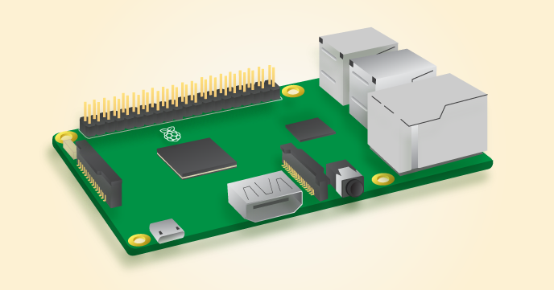
The Raspberry Pi has several ports that enable you to connect a variety of devices.
Input devices let you send data to a computer. The two most common input devices are a keyboard and a mouse. You can plug a USB keyboard and mouse into two of the four USB ports on the Raspberry Pi.
Output devices let the computer send data to a user. Two of the most common output devices are a monitor and speakers. You can connect an HDMI monitor or television to the Raspberry Pi using the single HDMI port. If you don’t have an HDMI monitor, then you’ll need to use an adaptor. You can connect speakers or headphones to the Raspberry Pi using the 3.5mm headphone port.
Storage devices are used to store data. On most computers this would be handled by a hard drive. Most modern computers, tablets and mobile phones now use Solid State storage devices. The Raspberry Pi uses a type of Solid State storage device called a microSD card. This will be used to store the Operating System, your software, and all the files you create.
The last thing you’ll need to do is provide your Raspberry Pi with power. For this, we use a micro-USB power supply.
The Raspberry Pi at first glance appears quite different to computers that most of use are familiar with.

Setting up the software
So you’ve got a Raspberry Pi, and you’ve made sure you have all the physical equipment you need. Now what? It’s time to get yourself an operating system and boot up your Raspberry Pi.
The recommended operating system for use with the Raspberry Pi is called Raspbian. Raspbian is a version of GNU/Linux, designed specifically to work well with the Raspberry Pi.
You have a couple of options when it comes to getting hold of a copy of Raspbian:
- You can purchase your Raspberry Pi together with an SD card pre-loaded with Raspbian, which should simply work out of the box.
- You can download the operating system for free from the Raspberry Pi website and put it onto a blank SD card.
Even if you purchase a pre-installed card, it’s worth knowing how to create your own.

Install Raspbian using Etcher
In order to set up an SD card so that it runs Raspbian, there are two steps to follow. First you will need to download a copy of the Raspbian image. Then you’ll need to write or ‘flash’ the image to the SD card.
- First you should download the latest Raspbian image from the Raspberry Pi website.
- In order to flash the image we recommend you download a tool called Etcher which makes this process really straightforward.
- Once you have downloaded the OS image and Etcher, insert your SD card (8GB+) into the computer or laptop’s SD card reader and make a note of the drive letter or name allocated to it, e.g. F:/.
- Load Etcher and click Select Image. You’ll then need to browse and select the OS image file you just downloaded (no need to decompress it).
- Click Select Drive an choose the drive that matches your SD card.
- Click Flash! and wait. In around 10 minutes you’ll have a Raspbian SD card ready to boot.

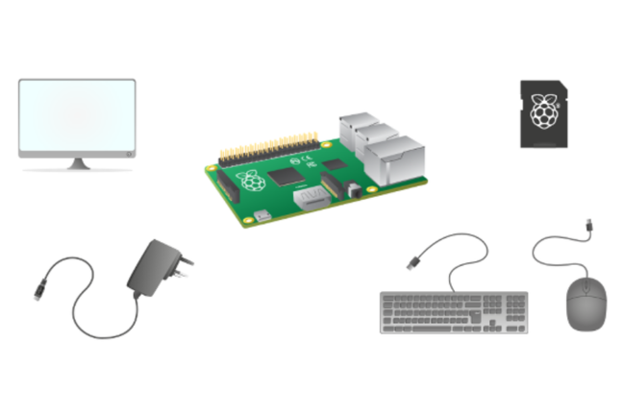
A Raspberry Pi computer with all its peripherals

Connecting all the things

Plugging in your Raspberry Pi
- Begin by placing your SD card into the SD card slot on the Raspberry Pi. It will only fit one way.
- Next, plug your keyboard and mouse into the USB ports on the Raspberry Pi.
- Make sure that your monitor or TV is turned on, and that you have selected the right input (e.g. HDMI 1, DVI, etc).
- Connect your HDMI cable from your Raspberry Pi to your monitor or TV.
- If you intend to connect your Raspberry Pi to the internet, plug an Ethernet cable into the Ethernet port, or connect a WiFi dongle to one of the USB ports (unless you have a Raspberry Pi 3 which has a WiFi chip already on the board).
- LAST : When you’re happy that you have plugged in the SD card and all the cables correctly, connect the micro USB power supply. This action will turn on and boot your Raspberry Pi.

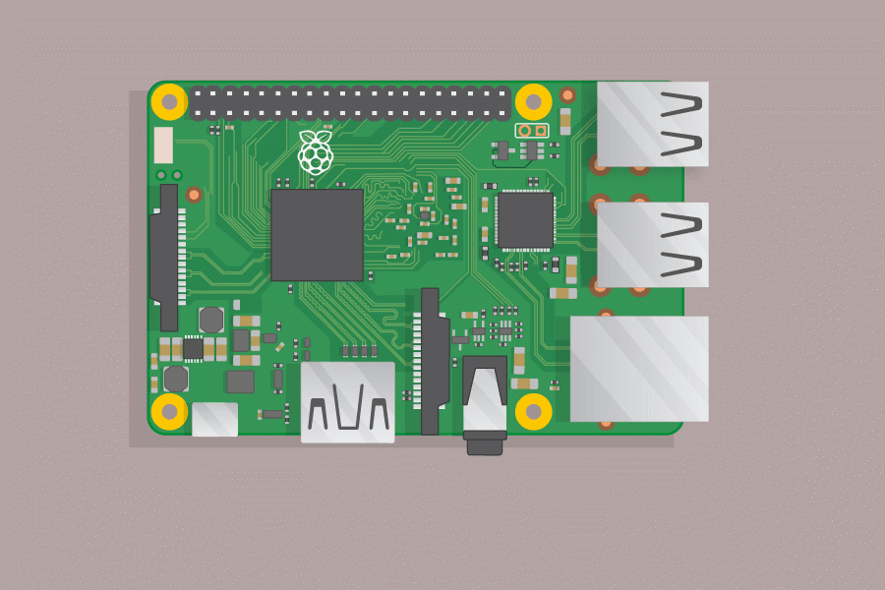

Connecting more devices
- Learn how to connect your Raspberry Pi to the world wide web
- Learn how to add extra storage to save your files
- Find out how you can connect headphones or speakers for audio output
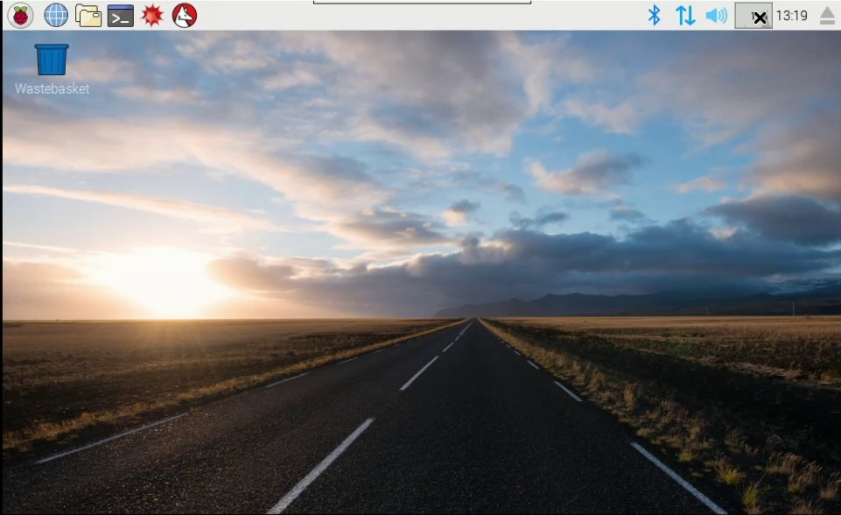

Loading the operating system
When your Raspberry Pi boots up, it will load its operating system. This is the software that manages the computer, and is responsible for managing all the peripheral devices and resources for the software you might run.
You’re probably used to operating systems such as Windows, MacOS, Android and iOS. Raspbian is the operating system recommend for use with the Raspberry Pi. It is based on a popular version of the free and open source operating system Linux, called Debian. Linux operating systems are extremely popular. Computers running Linux are installed on most of the servers on the internet. Even popular operating systems such as Android and ChromeOS are varieties of Linux. We’ve tried to make Raspbian as user friendly as possible, so you’ll probably notice that it shares many of the features you are used to.

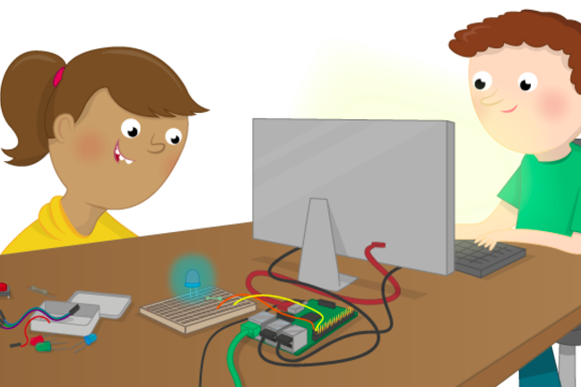

Troubleshooting your Raspberry Pi
If you have any problems getting started with your Raspberry Pi, here are some links to further guides to hardware and software and easy-to-follow instructions on getting started with the Raspberry Pi.
https://www.raspberrypi.org/help/

OTHER USEFUL links:
https://www.raspberrypi.org/
https://www.futurelearn.com/courses/physical-computing-raspberry-pi-python

